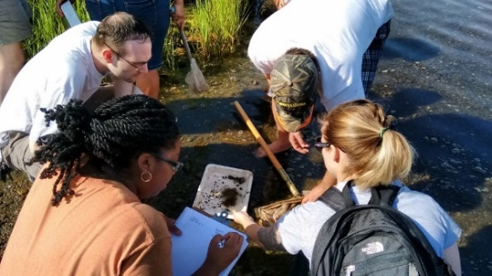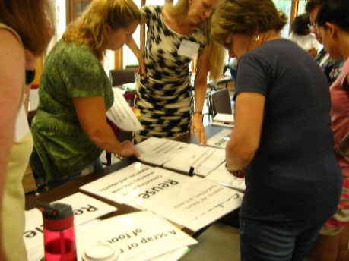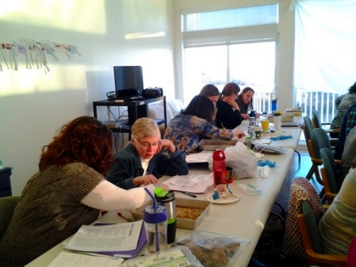

FE3: Facilitating Excellence in Environmental Education

Climate Simulation Workshop and Resources

July 14-16, 2020

**9:00 am – 3:00 pm per session**

**The workshop will be electronic to meet with changing health directives. Plan on these days to attend and devote this time frame.**

Three day professional development series for secondary, Upper elementary, and university education professionals, focused on bringing understanding of climate change action to students through interactive model simulation using the EN-ROADS Simulator from MIT. The three day training will provide educators with integration of environmental resources into curriculum. During your experience you will:

* **Receive a $100 stipend for your participation**
* Run climate action policy simulations for application with students.
* Work with state scientists to understand local **climate actions**
* Introduction to participation in the Climate Youth Summit for 2021
* Support NGSS applications to weather, climate and system understanding for data use, argumentation and presentation aspects.
* **Obtain a library of resources to support your curriculum. New climate materials & lessons**

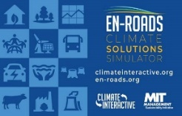

****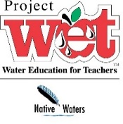**[](http://www.projectwild.org/)**

This series is open to all educators in the state of Connecticut. Registration is required and can be completed [electronically using this link](https://coeearegistration.wufoo.com/forms/zl2kjdh0w4yora/). For more information or to answer any questions please contact any of the state coordinators listed below.

Susan Quincy [susan.quincy@ct.gov](mailto:susan.quincy@ct.gov) Beth Bernard [bbernard@ctwoodlands.org](mailto:bbernard@ctwoodlands.org) Kristen Bellantuono [Kristen.bellantuono@ct.gov](mailto:Kristen.bellantuono@ct.gov) Susan Robinson [susan.d.robinson@ct.gov](mailto:susan.d.robinson@ct.gov)

