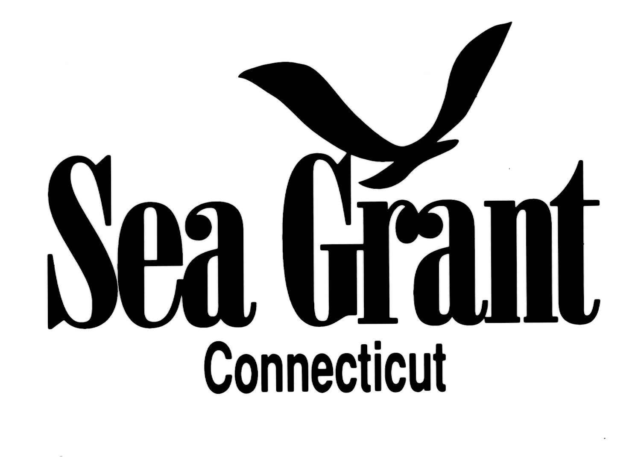
SEAFOOD HACCP TRAINING COURSE

September 12-14, 2017

8:00 am to 5 pm

University of Connecticut - Avery Point
Marine Sciences Building, Room 312, 1080 Shennecossett Road, Groton

Connecticut Sea Grant is offering the basic Seafood HACCP training course approved by the FDA. This course covers all seafood, including shellfish. All individuals completing the course will receive a “Certificate of Training Completion” from the Association of Food and Drug Officials. This certificate serves as proof that you have met the training requirement of the December 1997 FDA regulation. You must attend the entire class in order to receive your certificate.

Registration: $185 (includes 2017 training manual, most recent (2011) seafood hazards guide, training materials, $50 AFDO fee; refreshments; campus parking; lunch on 14th)

Lunch is on your own on the 12th and 13th. You can bring your own, purchase lunch at the cafeteria on campus, or leave campus for a nearby eatery.

The registration fee is non-refundable if you do not show up and do not call the office at 860-405-9128 to provide advance notice.

COURSE REGISTRATION BY SEPTEMBER 1st IS REQUIRED
FAX (860-405-9109) or EMAIL (nancy.balcom@uconn.edu) the registration form immediately to hold your spot in the class, which will be confirmed. Please DON’T send payment until late August in case your plans change.

PLEASE NOTE:
1. If you or someone in your firm already owns the 2011 FDA Fish and Fishery Products Hazards and Control Guide, please note this on form and deduct $25. YOU MUST BRING THE BOOK WITH YOU TO CLASS or access it through your laptop. We will use it frequently. It IS NOT feasible to try to read the material via a smart phone or a small tablet.

2. While the course is taught in English, the 2011 FDA Fish & Fishery Products Hazards and Control Guide and the 2011 version of the training curriculum are available in Spanish. Please indicate on the registration form if you prefer copies in Spanish.

Mail form with full payment payable to “Connecticut Sea Grant”:
Connecticut Sea Grant Extension Program
Attn: SEAFOOD HACCP Course
1080 Shennecossett Road
Groton CT 06340
EVENT ACCESSIBILITY STATEMENT: If you require an accommodation to participate in this event, please contact Nancy Balcom at (860) 405-9107; E-mail: nancy.balcom@uconn.edu by August 29th.

Parking on Campus

There is a charge to park at the University of Connecticut – Avery Point campus. You will receive by email a link to register your vehicle prior to 9/12. The $3/ day fee is included in the registration fee.

(OVER FOR DIRECTIONS)
DIRECTIONS:

Traveling I-95 northbound or southbound, take Exit 87 (Clarence Sharp Highway, Rte 349). (NOTE: For those traveling southbound on I-95, exit 87 is a LEFT exit.)

At second light (top of hill), take a right on Rainville Avenue. At next light, take a left onto Benham Road. Continue past Pfizer and the golf course to the University of Connecticut campus. Come in entrance and take your first left. At stop sign, go straight into parking lot D. Head toward three-story gray/green marine sciences building (past Project Oceanology). Go through the courtyard to the right of this building and enter the building from the plaza level at the top of the stairs. (TURN SILVER KNOB AS YOU PULL THE DOOR OPEN.)

Take the elevator to the 3rd floor and follow signs to Room 312.

FOR THOSE TRAVELING FROM A DISTANCE:

Here are a couple of reasonable hotels within a few miles of the campus:

Hampton Inn, Rte 1 (Long Hill Road), Groton; 860-405-1585

Best Western Olympic Inn, Route 12, Groton; (860) 445-8000

Groton Inn and Suites, Route 184, Groton; (860) 445-9784

REGISTRATION FORM - SEAFOOD HACCP COURSE
September 12-14, 2017 — Groton, CT

(PLEASE FILL OUT NAME and CONTACT INFORMATION FOR EACH PERSON ATTENDING)

Name: ____________________________________________________________
Company: ____________________________________________________________
Address: ____________________________________________________________
City: ________________________ State: ________ Zip Code: ___________
Tel: ________________ Email for parking registration link: _____________________________________________________
Special Needs / Dietary Restrictions? _______________________________________________________________________
Name: ____________________________________________________________
Company: ____________________________________________________________
Address: ____________________________________________________________
City: ________________________ State: ________ Zip Code: ___________
Tel: ________________ Email for parking registration link: _____________________________________________________
Special Needs/ Dietary Restrictions? _________________________________________________________________________

______ Number of 2017 new training guides (English) needed
______ Number of training guides (Spanish) needed
______ Number of 2011 Hazards Guides (English) needed**
______ Number of Hazards Guides (Spanish) needed

TOTAL: _________ x $185** PER PERSON = $________________

**Note: If you or someone in your firm already owns the 2011 FDA Fish and Fishery Products Hazards and Control Guide, please note this on form and deduct $25. YOU MUST BRING THE BOOK WITH YOU TO CLASS or access it through your laptop.

Mail form with full payment payable to “Connecticut Sea Grant” by October 14th to:

Connecticut Sea Grant Extension Program
Attn: SEAFOOD HACCP Course
1080 Shennecossett Road
Groton CT 06340

